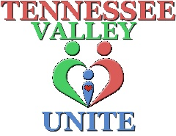
Tennessee Valley Unite, Inc.
Release and Consent Form
I hereby give permission to Tennessee Valley Unite, Inc. to use:
Photographs Audio Recordings Visual Recordings

Other ___________________________________________________________________

Description: __________________________________________________________________
Person/s Featured: ____________________________________________________________
I hereby authorize Tennessee Valley Unite, Inc., to edit, alter, copy, exhibit, distribute and publish in print, video, audio recorded productions and on the World Wide Web this material for purposes of publicizing Tennessee Valley Unite Inc., programs or other lawful purpose without payment or any other consideration.
By signing this document, I understand that:
- The materials will be used only for nonprofit/educational purposes
- Tennessee Valley Unite, Inc. will not release the materials to any other nonprofit or commercial entity without seeking my permission.
In addition, I waive the right to inspect or approve the finished product, including written or electronic copy, wherein my likeness appears. I hereby hold harmless and release and forever discharge Tennessee Valley Unite, Inc. from all claims, demands, liability and causes of action which I, my heirs, representatives, executors, administrators, or any other persons acting on my behalf or on behalf of my estate have or may have by reason of this authorization.
In addition, I would like to specify the following conditions for use of the materials:

This authorization is continuous and may only be withdrawn by my specific written rescission of this authorization. I have read this release before signing below and I fully understand the contents, meaning and impact of this release.
____________________________________________ _________________________________
Signature Date

